1. **What was the most impactful thing(s) you learned this week and why do you think so?**

I never practiced flexbox much in other courses because I found grid to be easier for me to use. I’m glad this assignment pushed me to use flexbox, though, because I can definitely see the benefits of using it! I definitely struggled this week to make the Prove assignment practice look like the screenshots, and I wonder if that was more an because I lack understanding of selectors at the moment. The cards were also generated with Java Script, which I also don’t have strong skills in. That being said, the concepts were easy enough to grasp and I enjoyed learning about flexbox this week.

1. **What questions do you have about this week's chosen topic(s) and/or exercises (first-time students) or websites you are working on (repeat students)?**

The one thing I got really stuck on during this assignment was making the vertical cards in the assignment line up at the bottom. When I used the row-wrap, the tops of the cards in each row aligned with each other, not the bottoms of the cards above them. Below is a screenshot of the issue… with all the resources provided, I couldn’t find a way to make the columns wrap vertically without messing up the orientation of the cards. I think this could be a selector issue like I mentioned above, any tips would be great!

1. 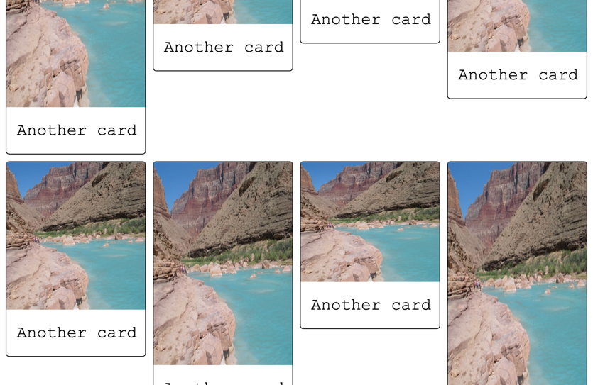**Would you like specific feedback from your instructor? If so, what things would you like feedback on? (Please use the Canvas calendar to schedule time to meet with your instructor or attend a study session.)**

It seemed like a lot of students were having trouble with this week’s assignment and I didn’t want to clog the slack channel with more questions, but any tips for the above problem would be really useful! I feel like I’m missing something very small but I don’t know exactly what that is.

1. **Where would you go next to learn more about this week's topic(s)? Give 2-3 links to resources that look promising to help answer the questions you indicated in the quiz question above.**

Here are resources about flex wrap that I should use to try to solve my issue:

<https://youtu.be/vQAvjof1oe4>

<https://stackoverflow.com/questions/43897090/can-flex-items-wrap-in-a-container-with-dynamic-height>

<https://developer.mozilla.org/en-US/docs/Web/CSS/CSS_Flexible_Box_Layout/Mastering_Wrapping_of_Flex_Items>

1. **Did you participate with the class on Slack? (You can participate by asking a question, answering a question, or sharing a resource you’ve found. Or you can share your thoughts on what you’re learning this week. Or you can answer any questions your instructor might have given in their announcement.)**

I participated in Slack this week by asking a few questions, responding to questions, and talking with my Zen Garden group.

1. **Please rate your success with learning and this week’s work on a scale of 1 to 4.**

I think I got a 3.5 this week, I tried my best but I also should have put in a bit more time trying to solve my issue with the Prove assignment.

* Please rate yourself at the level you feel most closely matches your learning; 1 is the lowest rating and 4 is the highest.
* Feel free to use decimals if you feel you must.
* Your answers to questions 1 through 4 are your justification for your rating.
* This is most of your grade for your reflection, you also receive one point for submitting the other required items.
  + Your instructor won’t grade your assignment until you submit the required items (screenshot, zipped files, etc.)
* If your instructor disagrees substantially with your rating, they can raise it or lower it to signal to you their expectations.
* If your instructor lowers your rating, your instructor might contact you to arrange a meeting to see how they can help you. Feel free to reach out to them as well.